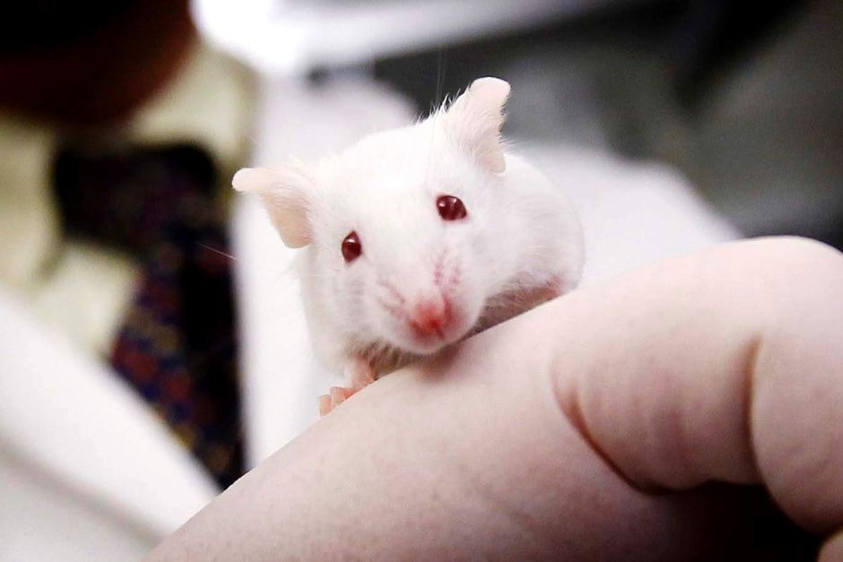
Office use only
Reference No:
Workshop on Basics of Laboratory Animal science

11th and 12th August 2015
Faculty of Medical Sciences
University of Sri Jayewardenepura

Registration Form

Name: (Prof. /Dr. /Mr. /Mrs. Ms.)

.…………………………………………………………………………………………………

………………………………………………………………………………………………….

Designation:……………………………………………………………………………………
Official Address/Place of Employment
……………………………………………………………………………………………….…
………………………………………………………………………………………………….

Phone:………………………… Fax:………………………. E-mail:………………………..

Payment slip: Attached/ not attached
Food Preference: Vegetarian / Non Vegetarian

…………………………………… …………………………………

Signature Date

Organized by Sri Lanka Association for Laboratory Animal Science
Registration fee: Rs. 3500 Closing date 08th August 2015
Please deposit your registration fee to Sri Lanka Association of Laboratory Animal Science,
A/C No.167-2-001-2-0007451, Peoples Bank, Kynsey Road branch and send us the bank receipt along with the attached registration form. You may email the scanned bank receipt with the completed registration form.
Phone: 071 82 21 738 (Dr. Peshala), 071 32 74 841 (Ms. Ureshani) Email: slalasci@gmail.com
Email: slalasci@gmail.com

