Research Council- University of Sri Jayewardenepura

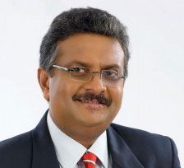
Head

Vice Chancellor – Prof. Sampath Amarathunga

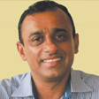

Co- Chairmans

Prof. N.M. Pathmalal (Department of Zoology,
Faculty of applied Sciences)

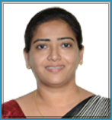

Dr. Pradeepa Jayawardana (Department of Pharmacology, Faculty of Medical Sciences

Governing Body

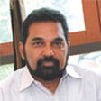
- All the Deans of Faculties

Prof. Sudantha Liyanage (Faculty of Applied Sciences)

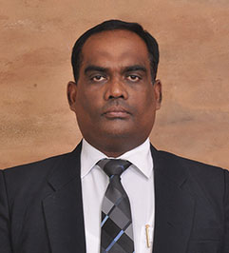

Mr. C.L.K. Navarathna (Faculty of Humanities and Social Sciences)

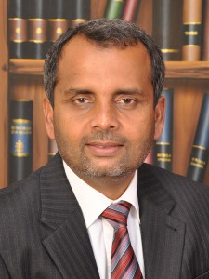

Dr. U. Anura Kumara (Faculty of Management Studies and Commerce)

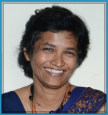
Prof. S.G. Yasawardene (Faculty of Mediacl Sciences)

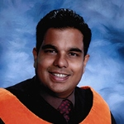

Dr. S.A.A.M. Subasinghe (Faculty of Engineering)

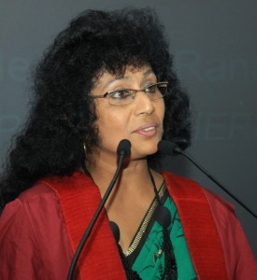
Prof. Hemanthi Ranasingha (Faculty of Graduate Studies)

- Faculty Representatives

Prof. N.M. Pathmalal (Faculty of Applied Sciences)

Dr. Pradeepa Jayawardane(Faculty of Mediacl Sciences)

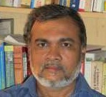

Dr. D. P. S. Chandrakumara(Faculty of Humanities and Social Sciences)

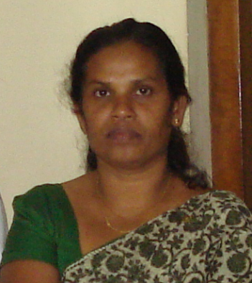
Prof. (Mrs) R.Lalitha.S. Fernando (Faculty of Management Studies
and Commerce)

- Invitees
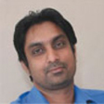

Dr. Pradeep Jayaweera

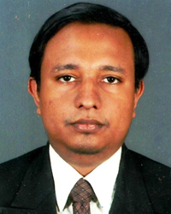

Dr. A. Roshan Ajwad

- Convener
Mr. Wasantha (Research and Publication Senior Assistant Registar)

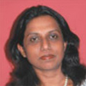
Research centers published under the research council

Center for Advanced Material Research
Cordinator- Dr.(Mrs.) N. Kottegoda

Center for Water Quality and Algea Research
Cordinator- Prof. N.M. Pathmalal
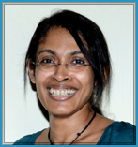
Center for Dengue Research
Cordinator- Prof. Neelika Malavige

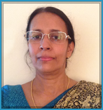

Ceneter for Cancer Research
Cordinator- Dr. Bimalka Senevirathna

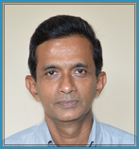
Center for Kidney Research
Cordinator- Prof. Hematha Peiris

Center for Multidisciplinary Research
Cordinator- Dr. D.P.S. Chandrakumara

Center for Management Studies and Commerce
Cordinator- Prof. Y.K. Weerakoon Bandara

