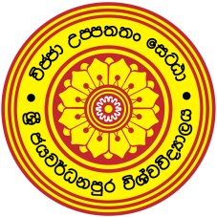
University of Sri Jayewardenepura
Faculty of Humanities and Social Sciences
Certificate Course in English – Intake 12 (2019/2020)

Applications are invited from suitably qualified individuals for Certificate Course in English (Intake-12) offered by the Department of English Language Teaching (DELT) of the Faculty of Humanities and Social Sciences, University of Sri Jayewardenepura.
Lectures and practical sessions will be conducted on
Sundays from 8.00 am to 5.00 pm
Duration: 225 hours
Course Fee: Rs.20,000/-( Full payment must be paid at the time of the registration )
Eligibility:
- Pass G.C.E. (O/L) with English as a subject or any other professional or academic qualification acceptable to the university

Walk-in-interview : 07th & 08th September 2019
Time: 9.00a.m.-12.00 noon
Venue: Faculty Board Room of the Faculty of Humanities and Social Sciences
Commencement of the Course: 29th September 2019
The following documents should be brought for the interview.
- Duly filled application form (could be downloaded from (http://fhss.sjp.ac.lk/) OR obtained from the DELT, Faculty of Humanities and Social Sciences.)
- Deposit Slip for application fee of Rs.300/=. paid to the Account No. 013010001306 at any branch of the People’s Bank .
- Relevant certificates
- Two passport size colour photographs
- Two stamped self-addressed envelopes (Rs.35/= each)

Further information:

Course Coordinator
Department of English Language Teaching (DELT)
Faculty of Humanities and Social Sciences
University of Sri Jayewardenepura
Gangodawila,
Nugegoda,
Sri Lanka.
Contact: 011 2802499

Registrar
University of Sri Jayewardenepura
Gangodawila,
Nugegoda,

