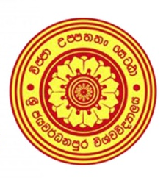
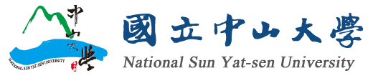

INVITATION

Joint Symposium by National Sun Yat-sen University, Taiwan &
University of Sri Jayewardenepura
on
“Towards a Better Environment: Challenges and Solutions”
29th November 2019

The Symposium is organized to protect the environment to guarantee a better public health to ensure its lasting survival for our future generations and a guiding light to the world by adding value utilizing cutting-edge technology.

To address the challenges by environmental changes, we are honoured to organize the Symposium on “Towards a Better Environment: Challenges and Solutions” in collaboration with National Sun Yat-sen University (NSYSU), Taiwan. (http://www.nsysu.edu.tw/)

Date: 29th November 2019
Time: 02.00 PM to 04.30 PM
Venue: Auditorium, Faculty of Applied Sciences, University of Sri Jayewardenepura

The symposium will be graced by the following Key Speeches, followed by a Brainstorming session.

- Air pollution, Environmental Changes and Public Health: Current Challenges in Aerosol Science Studies by Prof. Chia C. Wang, Director, Aerosol Science Research Center, NSYSU

- Wonders of Nature: Writes the Story of Slow Dance of Molecules by Prof. Nilwala Kottegoda, Department of Chemistry, Faculty of Applied Sciences, USJP

-Mineral Dust Aerosols: Air We Breathe and Climate Change by Prof. Pradeep M. Jayaweera, Department of Chemistry, Faculty of Applied Sciences, USJP

The Symposium will have a key focus on:
- Joint/Split double M.Phil/Ph.D programs
- Tuition waiver scholarships by NSYSU
- Multidisciplinary research collaborations leading to innovative product development with NSYSU, Taiwan and USJP.
- Public Private Partnerships linking industry and academia leading to product development targeting the global market
It is a great honour to invite you and interested members from your organization to participate in the Symposium and the interactive session.

Please confirm your participation by sending an email to wcup@sjp.ac.lk
Contact:
Prof. Ranil de Silva
Director. World Class University Project
University of Sri Jayewardenepura
0112758697
https://www.sjp.ac.lk/wcup/
wcup@sjp.ac.lk

