First Prize for Best Research Poster Presentation Award at the IBRO-APRC Associate School of Neuroscience on Neurological Disorders at Mohan Lal Sukhadia University-India, 2019
Mr. Yoonus Imran
Mr. Yoonus Imran, Research student, Department of Anatomy, Interdisciplinary Center for Innovation in Biotechnology & Neuroscience, has secured the best research poster presentation award and a first prize shield at the International Brain Research Organization- Asia Pacific Regional Committee (IBRO-APRC) Associate School of Neuroscience on Neurological Disorders at Mohan Lal Sukhadia University-India (https://ibro.org/events/2019-08-06/) by competing with 40 candidates from IBRO-APRC region.
Title of the poster presentation: “Cognitive Impairment Difference in Parkinsonism, Huntington’s disease and Spinocerebellar Ataxia: Sri Lankan Study”
Research Scholars under the supervision of Prof. Ranil de Silva, The Director, Interdisciplinary Center for Innovation in Biotechnology & Neuroscience (ICIBN- USJP) have received international awards for their research poster presentations since 2016,
- Best poster presentation award from National Institute of Advanced Industrial Science and Technology （AIST), Japan in 2016. AIST Japan ranked as the 5th in the top innovators globally by Thomson Reuters.
(https://www.reuters.com/innovation/most-innovative-institutions-2017/compare# )
- Two awards for best poster presentation from The Asia Pacific Societies for Neurochemistry (APSN) in 2016.
(https://www.sjp.ac.lk/news/best-poster-presentation-awards-for-the-two-postgraduate-students/ )
- Best poster presentation award and a gold medal from National Institute of Advanced Industrial Science and Technology (AIST), Japan in 2017.
(https://www.sjp.ac.lk/news/mr-nalaka-wijekoon-won-the-best-poster-presentation-award-and-a-gold-medal-at-japan/)
- Best poster presentation award International Brain Research Organization- Asia Pacific Regional Committee (IBRO-APRC) in 2017.
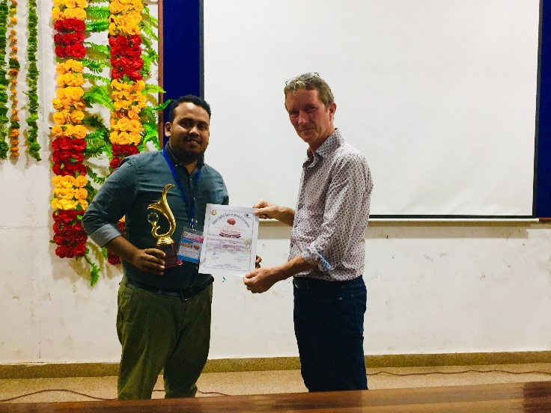
Award from - Prof. Noel Buckley, Professor of Neurobiology, University of Oxford, UK

